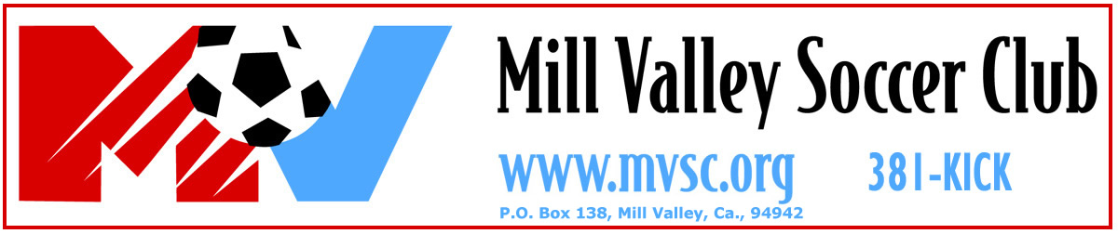

2008 Mill Valley 4v4 Tournament

U9 ~ U10 ~ U11 ~ U12 ~ U13 ~ U14
Boys and Girls

Sunday, August 3, 2008

The inaugural Mill Valley 4v4 Tournament will be held on Sunday, August 3, 2008, in Mill Valley. The games will be played at the Mill Valley Community Center Complex. The tournament is competitive yet open to competitive and recreational teams for the following age groups: U-9, U-10, U-11, U12, U-13, and U-14. All teams play a total of 6 games (20 minutes each) throughout the day.

The tournament is open to all USSF affiliated members. (e.g. CYSA, US Club) Teams not registered with USSF must show proof of medical insurance coverage for each player.

Cost: $300 per team
Eligibility: Registered U-9, U-10, U-11, U12, U-13, and U-14 boys and girls
Roster: Teams of 4-10 players (recommended maximum 10)
Check-in: All teams must Register between 7:30 a.m. - 8:30 a.m. regardless of what time they play.
Sign-up: Each team must send in a team registration form and check for $300.

Registration Deadline: July 15, 2008

- Games are 20 minutes long
- Each Team will play six games
- No use of hands is permitted (no goalkeepers)
- Unlimited substitution (referee’s discretion)
- Teams will be matched in the afternoon according to their point standing after the morning games.
- Point Configuration: 3 points for a win, 1 point for a tie, and 1 point for each goal up to 3 goals – tie breaker is head-to-head then goal differential
- Field will be approximately 22x32 yards.

____________________________________________________________________
For further information call (415) 381-KICK or visit our website at www.mvsc.org.

